How to set up cron in windows.
Before use these setting, make sure you change the directory in the .bat script. 1st cd after :a is to set the app folder and the script to execute.
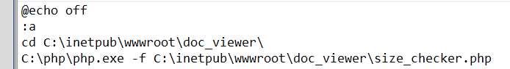
2nd cd after the timeout is to change directory to folder where we put the bat file.
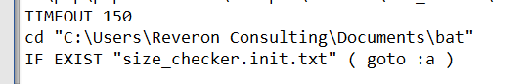
After the above setup is done, then we can proceed to setting up the task scheduler.

- Start and search for Task Scheduler
- Click on Create Task…
- Follow the following setting

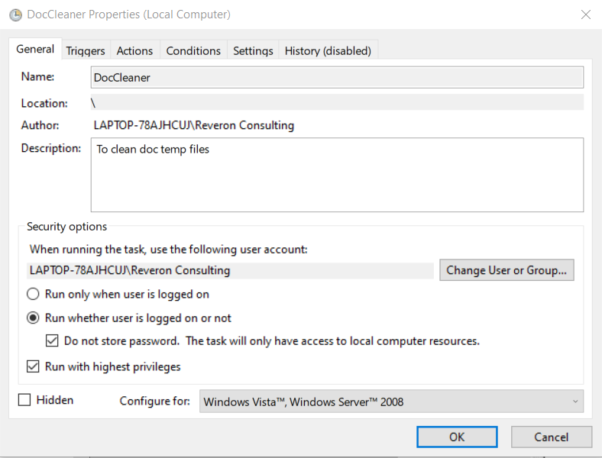

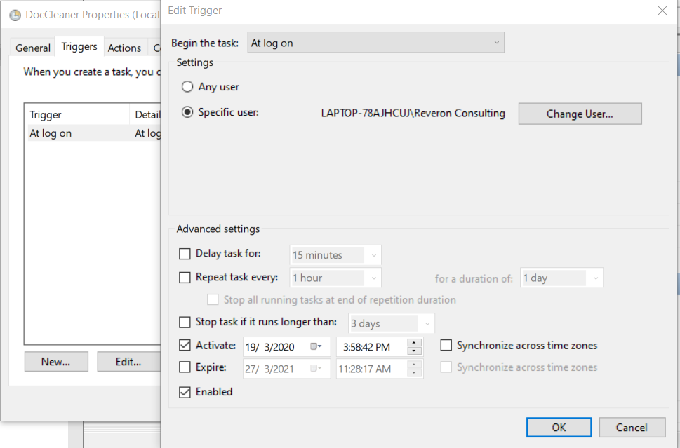

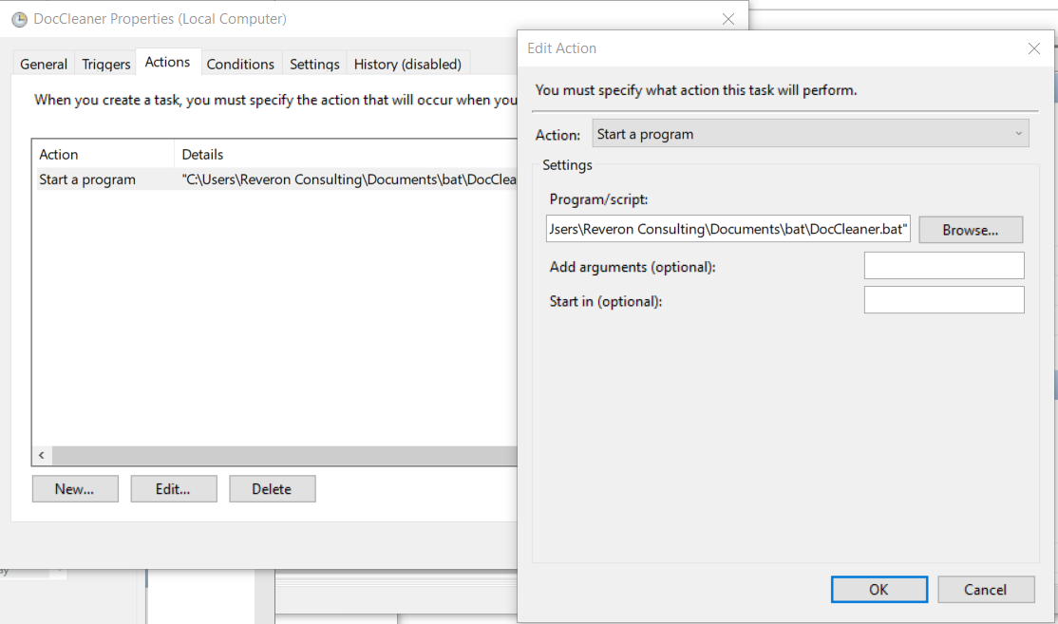

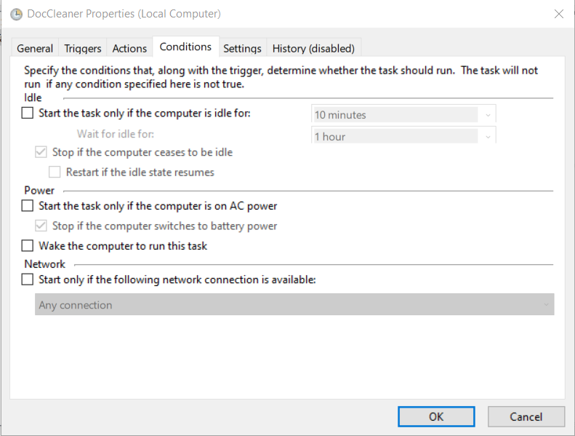
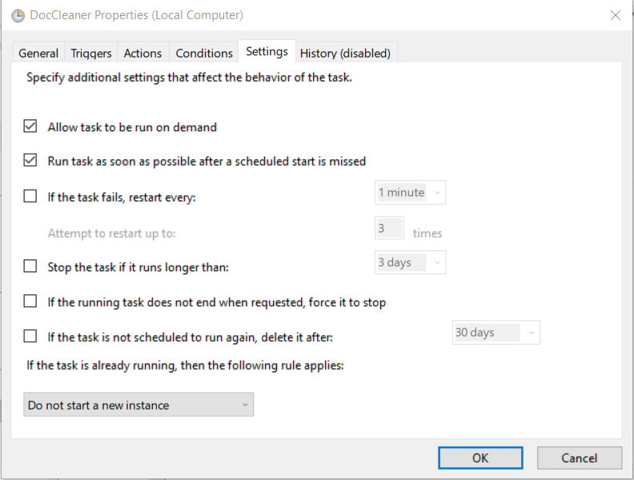
No need to bother about the History Tab. After done, the we can run manually or if the server restarted, it’ll run automatically.

